Chapter 17, Problem 24.

In the periodic function of Fig. 17.62,

- find the trigonometric Fourier series coefficients a₂ and b₂,
- calculate the magnitude and phase of the component of f(t) that has ω_{n} = 10 rad/s,
- use the first four nonzero terms to estimate f(π/2),
- show that

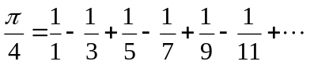

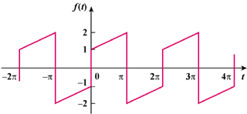

Figure 17.62
For Prob. 17.24.

